**HCI Project-Phase I**

Laiba Sajid-30502

Shahmeer Khan-25156

Abdus Samad Khalid-25273

Nosherwan Shaikh-25237

**Survey analysis**

As part of our development of the **Bookme** interface, we conducted a survey with a sample of 50 participants to gain valuable insights into the app’s user experience and to compare it with other ticket booking platforms. The survey aimed to explore key elements of an acceptable interface focusing on aspects such as ease of use, visual design, navigability, and overall user satisfaction. The following were the results of our analysis that we considered important factors.

**Highest education level**

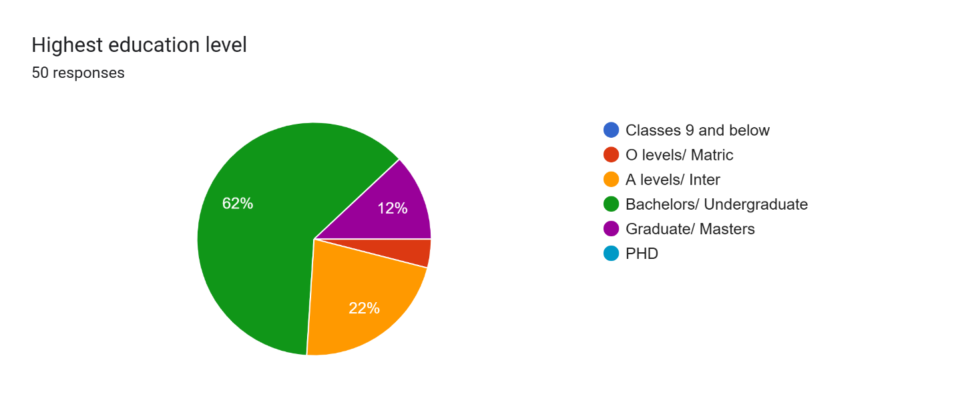

This was a way to gauge whether or not our customer base is well equipped with knowledge of how the world works, i.e. a student from lower classes could struggle understanding more complex interfaces and advanced features whereas the opposite would prefer simpler designs. A background understanding as such is necessary to guide us in our design process. Judging from these statistics, we can assume that our audience who is at the very least doing bachelors or a-levels would have a smaller learning curve with more complex features if we were to implement them.

**Industry of occupation**

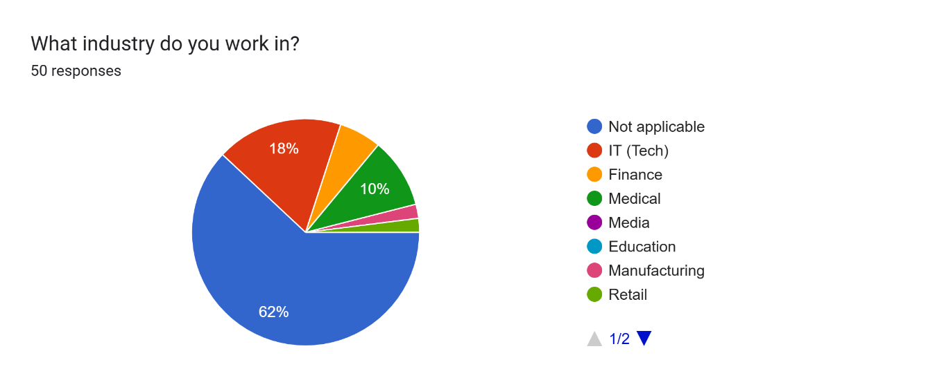

A majority in not applicable was due to the majority of our sample size being students, however by basing off which industries they are linked to we can cater to their needs accordingly i.e. individuals from the IT industry would be comfortable with more tech-oriented features, someone in media would appreciate the aesthetics and layout of your website a lot more, medical backgrounds would mean comparatively less tech savvy people and thus simpler features to get their tasks done. Finance background users would be very critical of our transaction processes and thus would also wish for several payment modes.

**Familiarity with technology**

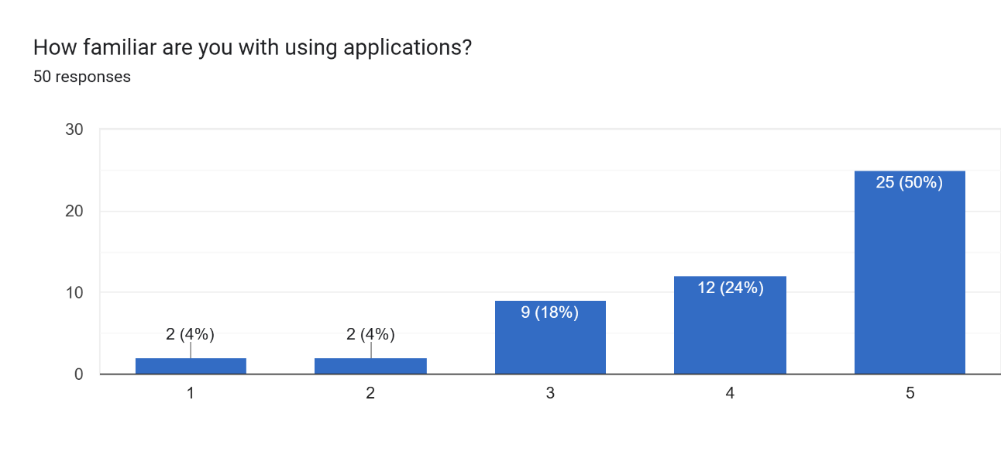

This is self explanatory but the more our customer base is comfortable with applications and technology, the lesser we have to worry about pinpointing the use of every single button and action, in this case a majority being very comfortable with tech.

**Disabilities**

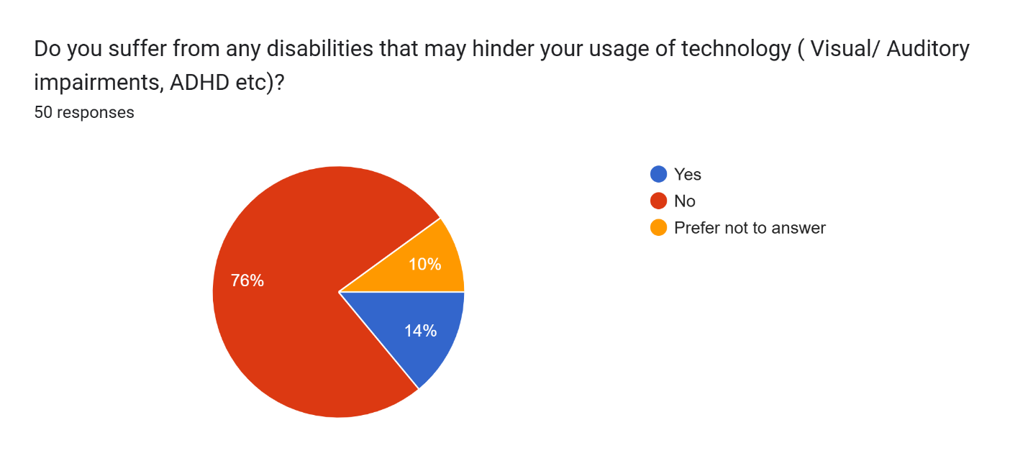

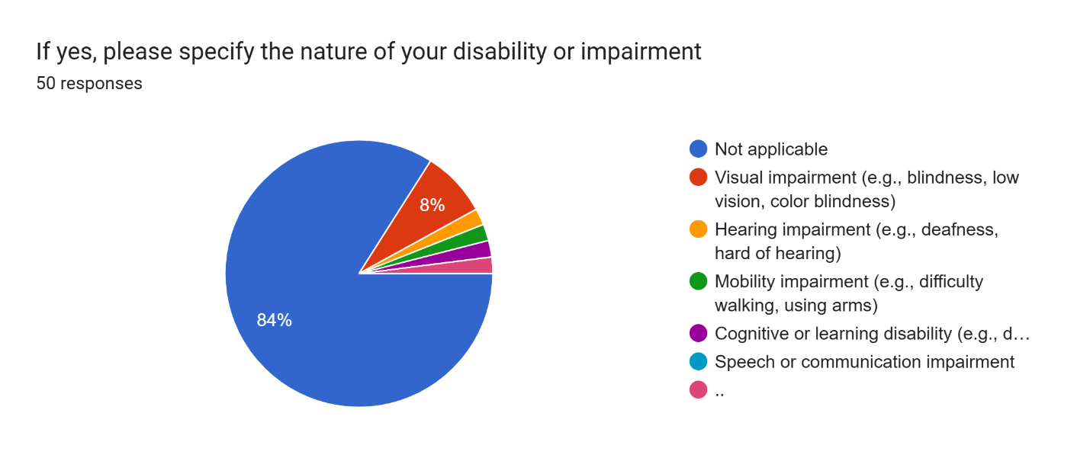

Forms response chart. Question title: What types of solutions or accommodations do you prefer to help with your disability or impairment? (Choose all that apply)  
. Number of responses: 50 responses.

While potentially in the minority, individuals with disabilities are just as valuable as those without and so understanding them accordingly and catering to their needs is imperative. By getting a deeper insight into what exactly the majority of disabilities are, we can leverage our focus to target the more dominant issues, i.e. visual impairment is relatively common these days thus being the most dominant feature here. By then further analyzing what solutions a customer would prefer, to aid with their impairments in terms of accessibility features, we can narrow down the most important features to implement in our design for example in our survey, cognitive support, simplified navigation and magnification softwares seem to be preferred by most users.

**Ticket booking platforms**

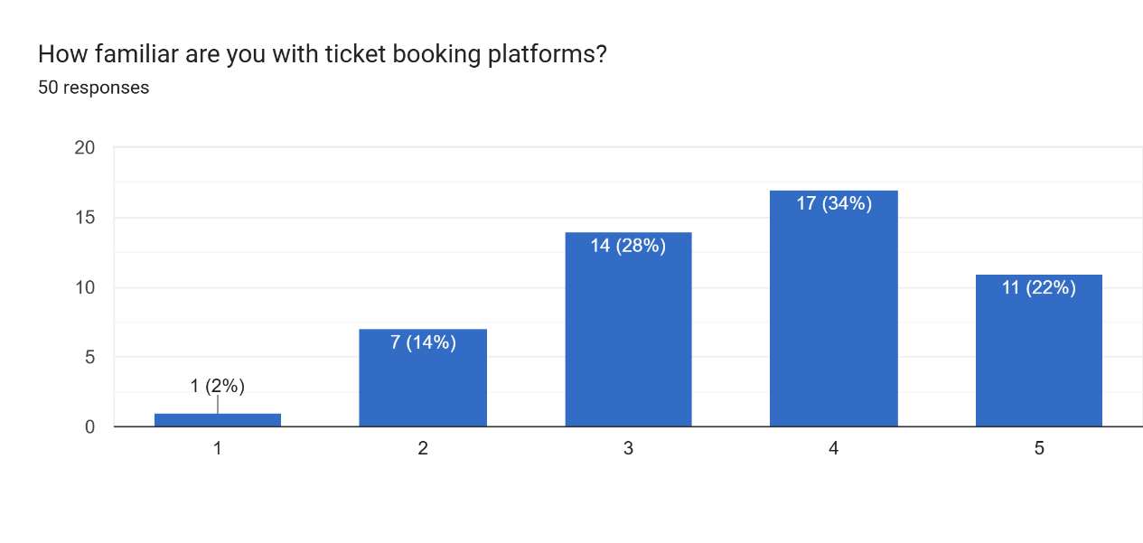

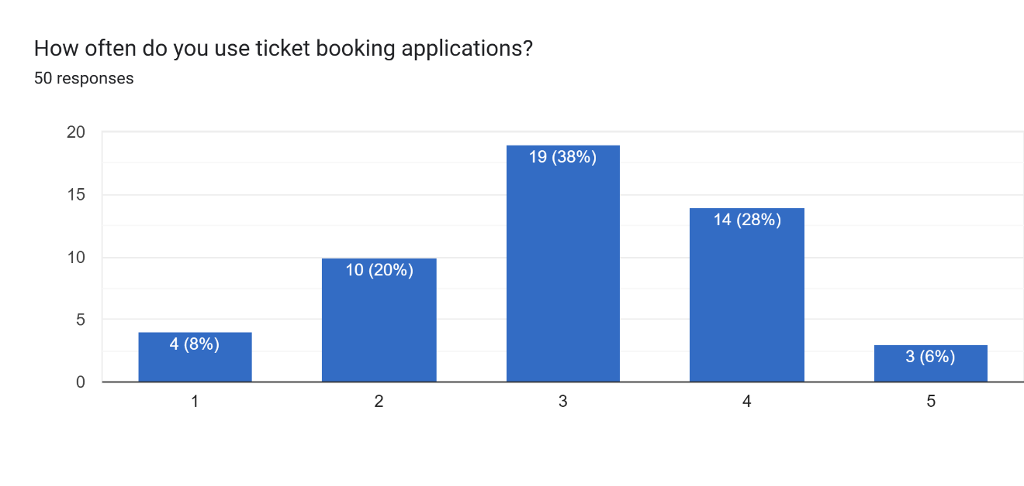

We then took to our main problem i.e., ticket booking platforms, by getting a brief idea firstly of whether or not our sampled individuals have awareness of these apps. After awareness comes usage which is a very important metric as we can use this to see how much a user would access these apps, ranging from 1 (barely) to 5 (all the time). This allows us to understand whether or not our sampled individuals are frequent users as well. Since, a majority of them use ticket booking apps at least sometimes alludes to the fact that the insights from them could be of use.

**Competitor analysis**

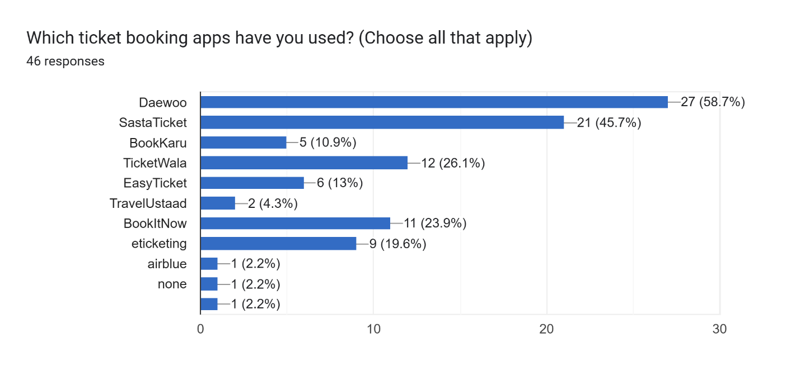

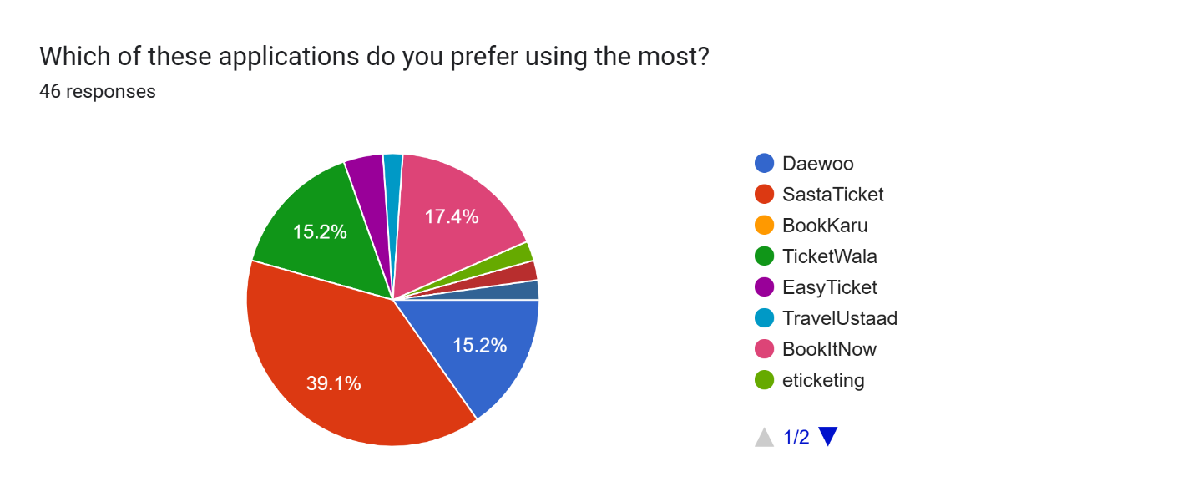

This question served to understand who our biggest competitors were, in terms of interface design this is crucial as we can then see what these companies do better and worse than us to find our strengths and weaknesses accordingly and improve based on those factors. Among these Daewoo obviously has something over the rest in terms of a larger userbase however a deeper dive shows that the majority of users prefer Ticketwala and Sastaticket over it. This could guide our project in terms of seeing what attracts customers to Daewoo and what keeps them engaged and loyal within Ticketwala and Sastaticket.

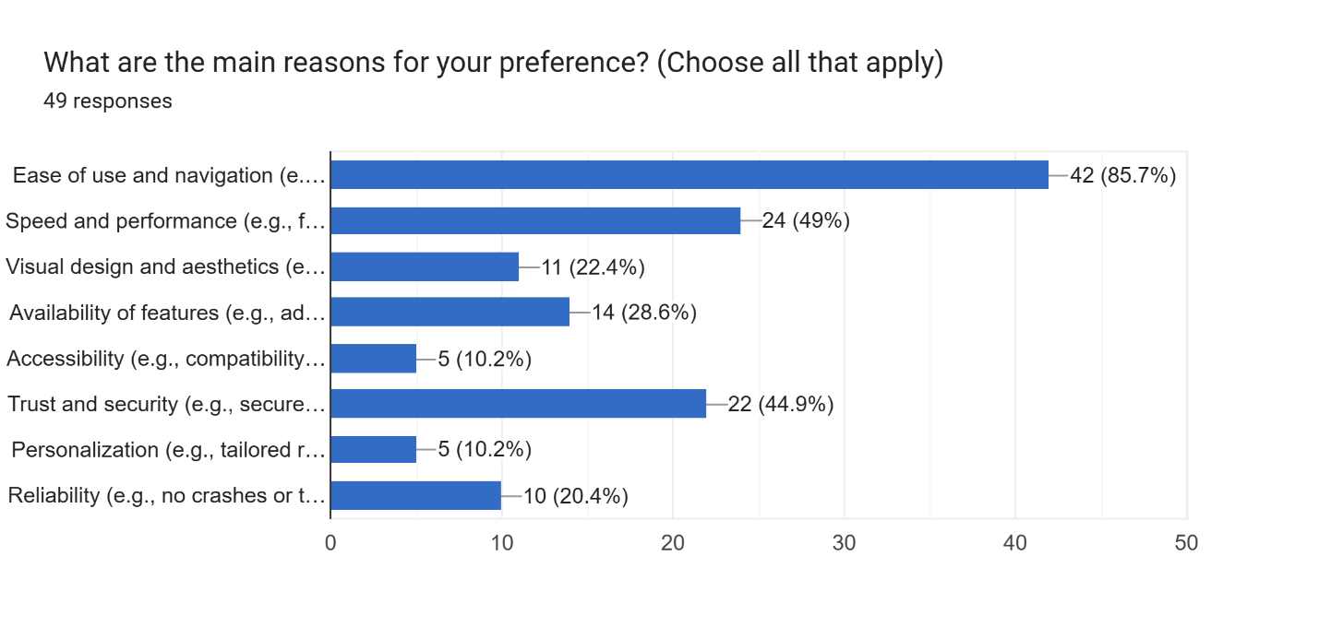

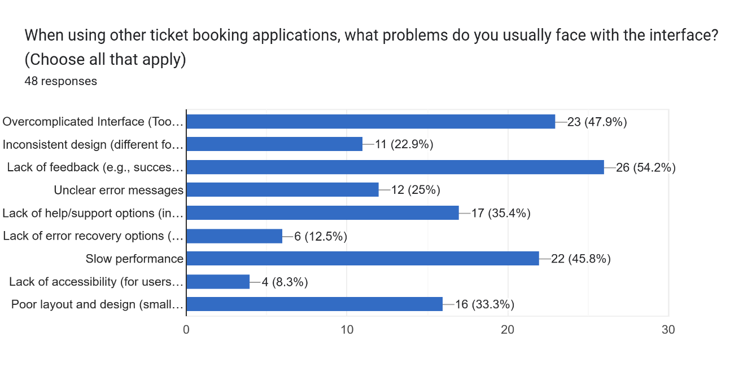

We then checked what exactly about these apps held customers and the majority vote was for ease of use and navigation meaning this is something we definitely have to focus on when designing our interface to make sure audience retention is maintained. We also then look among the lesser used and preferred apps to find reasons users may deter from them. The major ones being overcomplicated interfaces, lack of feedback and slow performance, all three are integral in determining the quality of an interface for user experience needing heavy emphasis.

**User insight**

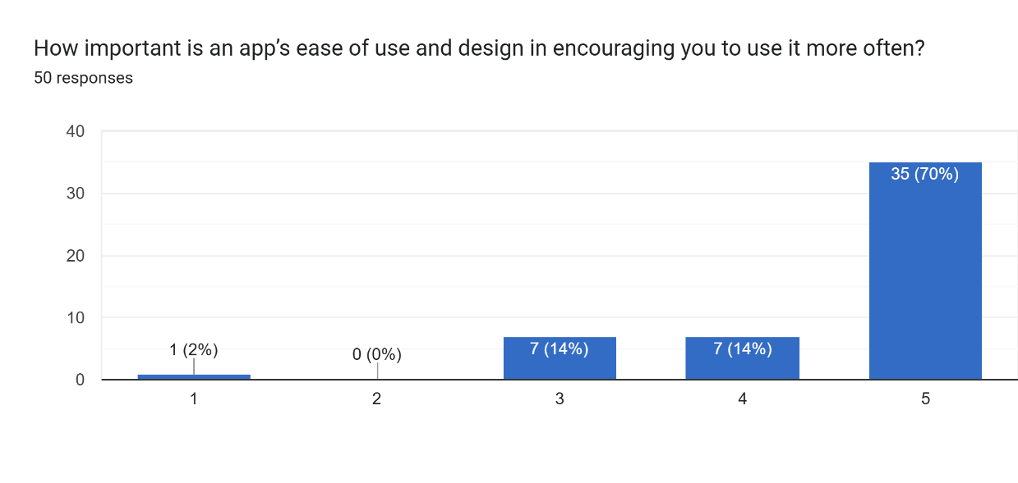

This was a more generalized question to see whether or not users care about ease of use and design and how much it affects their view of an app and thus future use, with the majority opting for maximum importance for these two factors further highlighting the need for ensured quality when it comes to user interaction with the software.

**Bookme based questions**

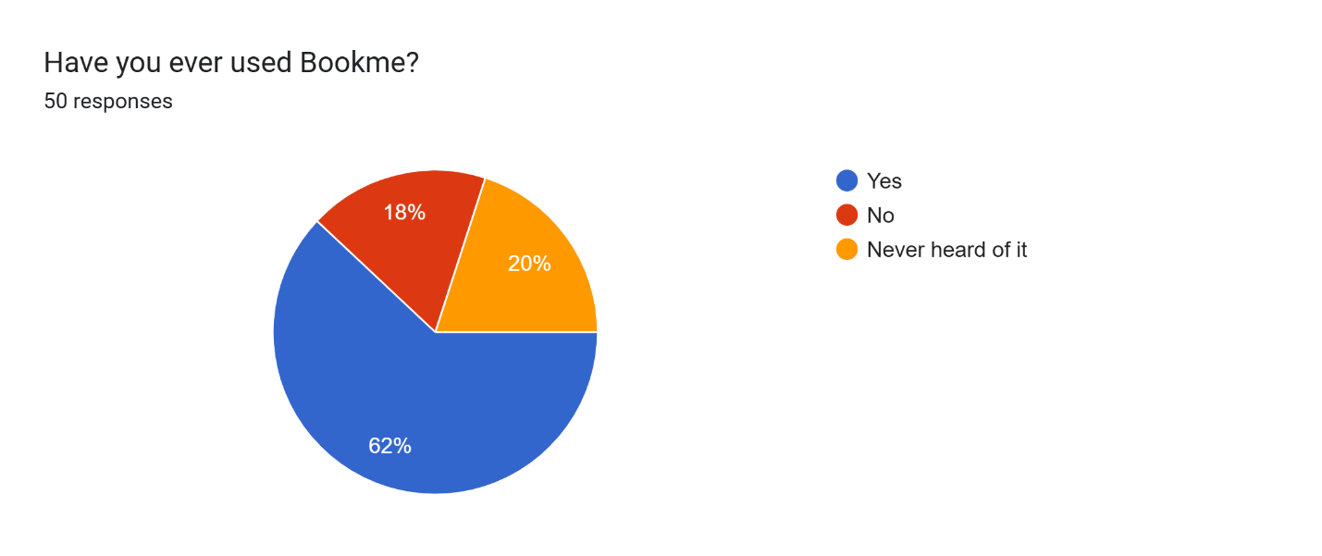

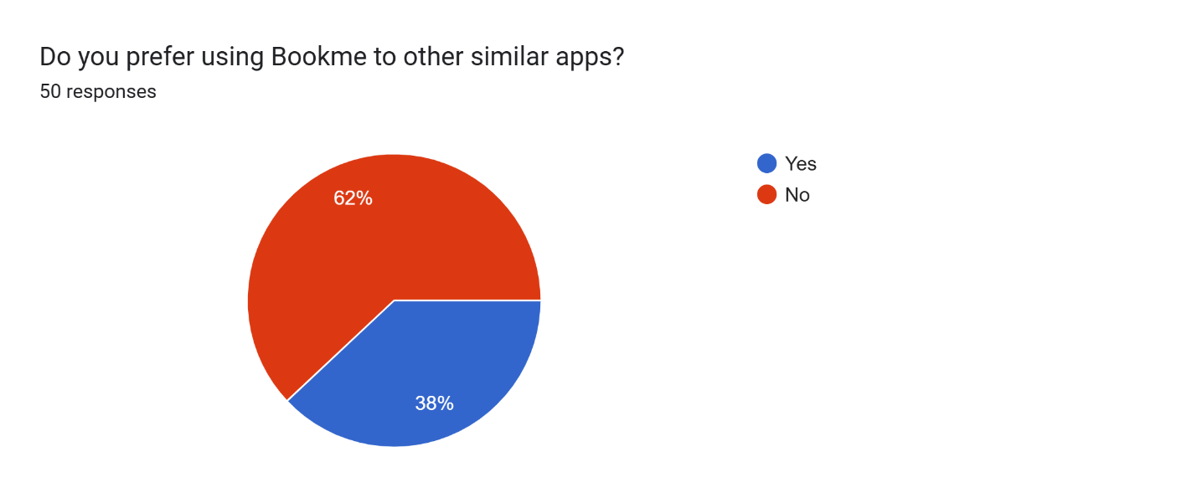

The first two questions are more generalized firstly gauging how many of our sampled users have actually used bookme, luckily a majority. The next part being whether they prefer bookme to the previous similar apps and this is siding to a negative, meaning there’s definitely room for improvement for bookme to increase their userbase, as while a lot of people have used the app, they wouldn’t choose it over others.

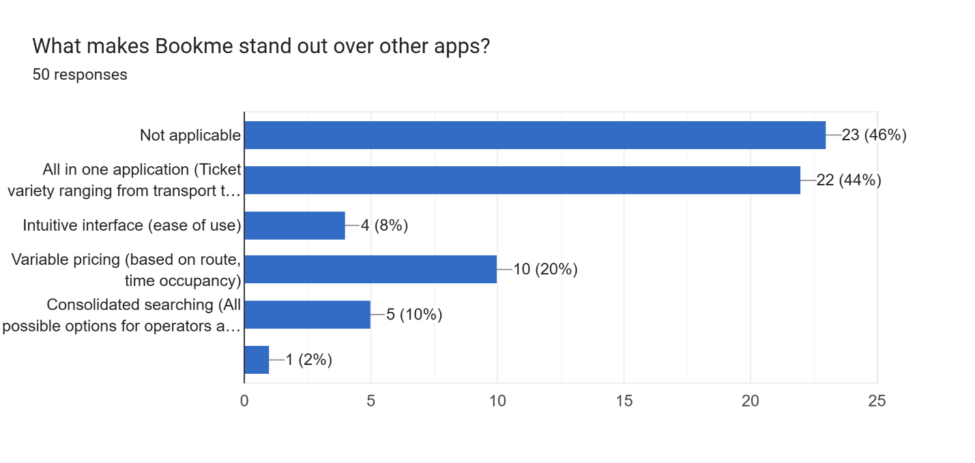

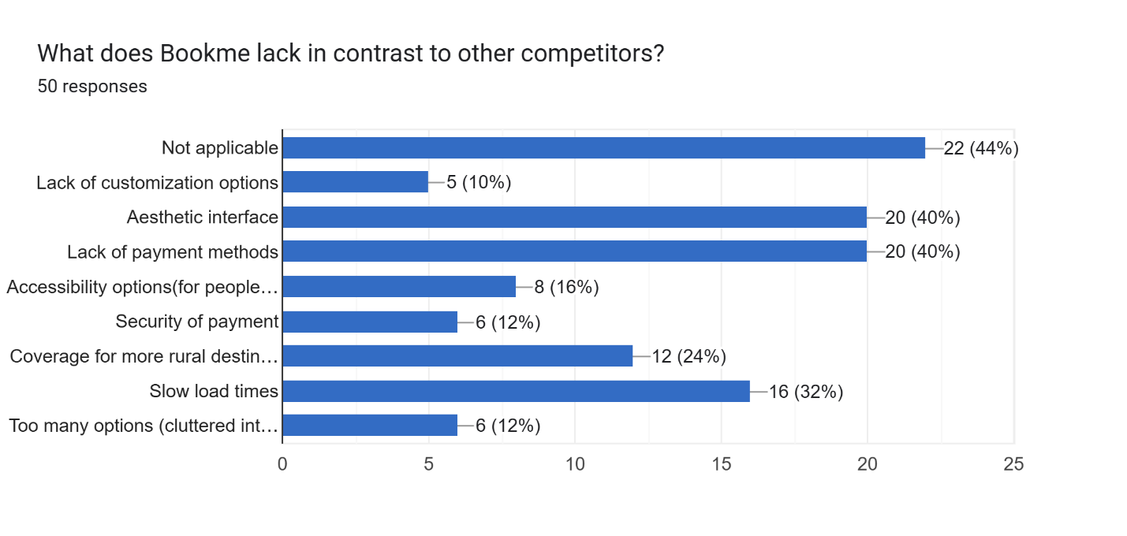

We then take a look at the strengths and weaknesses of bookme, in terms of positives it’s clear that bookme’s biggest attraction is its wide variety of ticket options ranging from travel to events to movies etc, followed by their variable pricing plans. The factors holding bookme back, on the other hand, include an aesthetic interface for starters, this is a clear indication that bookme’s focus on simplistic and an easy-to-use interface overshadows the need for aesthetics, the app is unappealing to look at turning customers away. Furthermore, a lack of payment options is another major factor as well as slow load times.

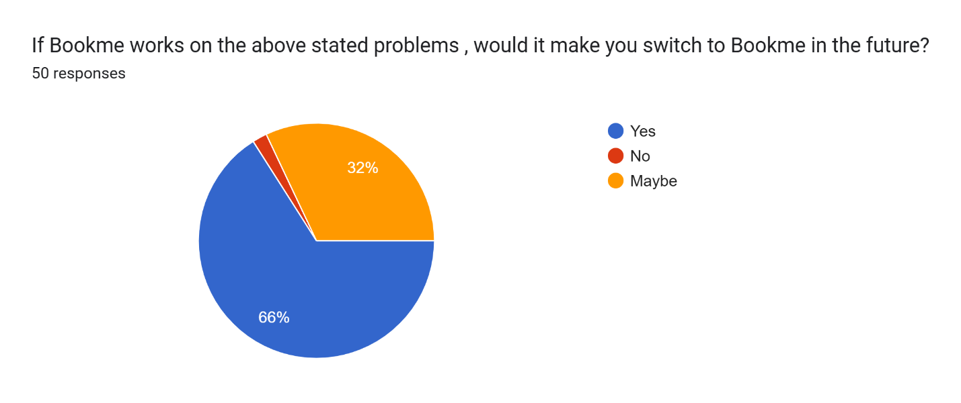

This question further confirms that half of the sampled users that preferred other apps would end up switching over to bookme if these strengths were polished and the weaknesses were dealt with. These incentives would be enough to at the very least motivate users to give bookme another chance.

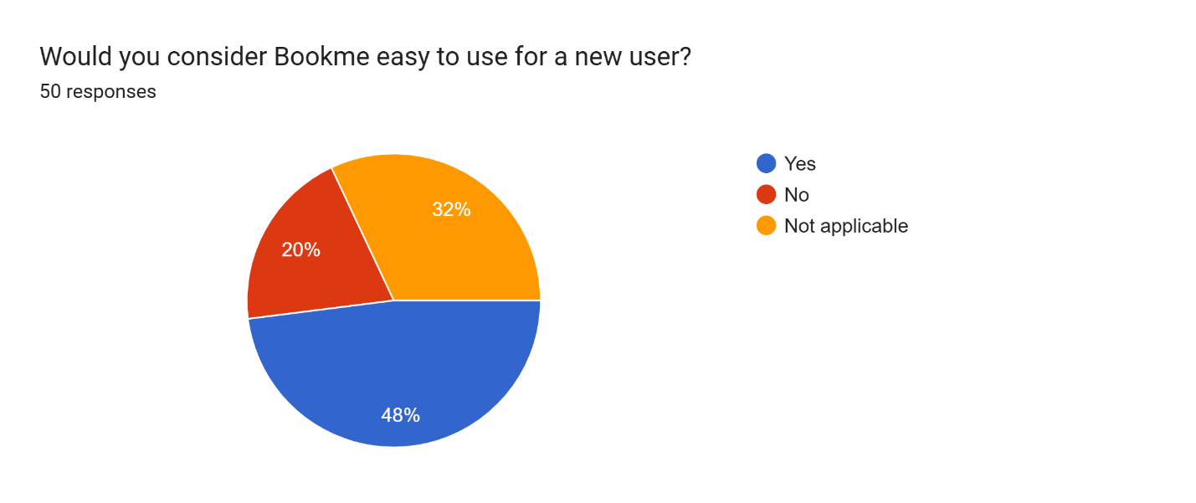

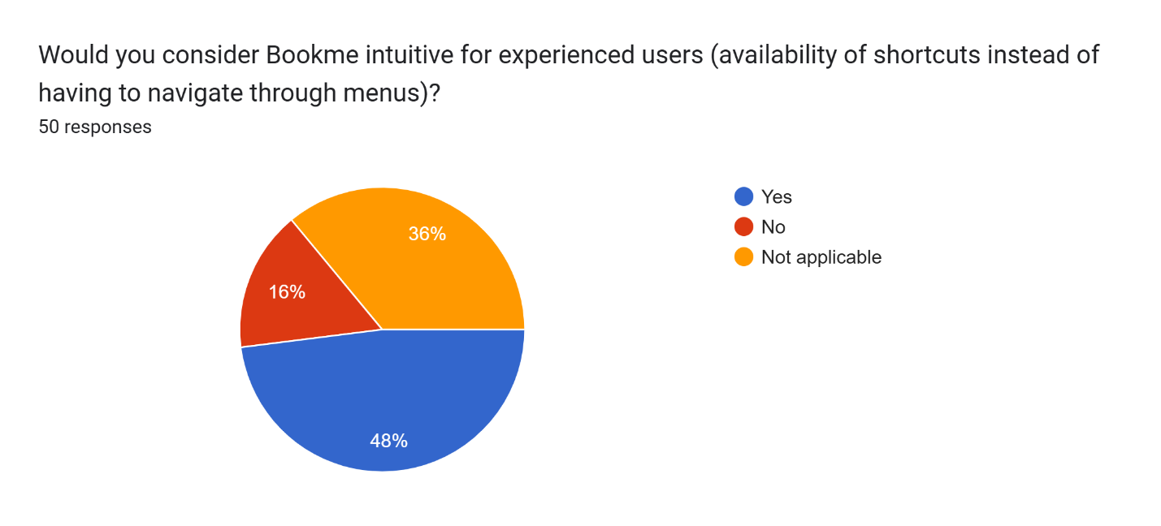

These are benchmark questions testing the learnability principle and also the use of shortcuts for bookme. We can see that our survey states a majority of users find bookme easy to use for a beginner which means it has high learnability, as well as shortcuts are also in the majority stating that the existing shortcuts aid in improving user flow, however the numbers still could be improved and thus should not be discarded as a potential issue.

**User suggestions**

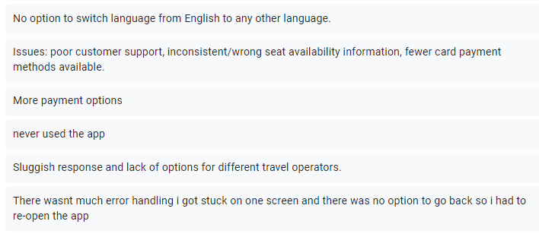

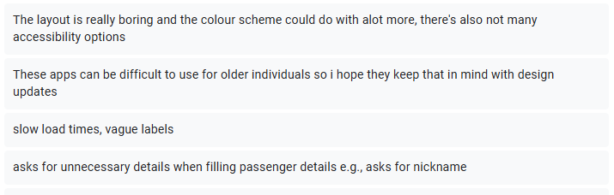

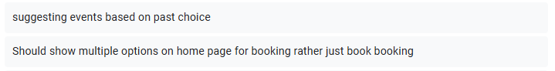



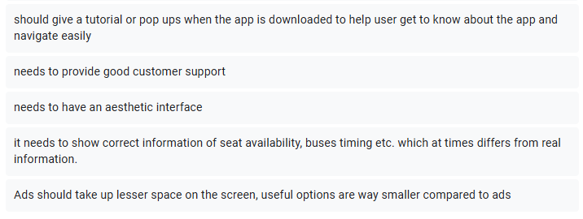

These suggestions help a great deal as they lean into personalized problems users may face, for starters a lack of languages, being dominant in Pakistan and offering rural options, the app needs an Urdu language version as well, as a majority of the populus is not well versed in English.

The second suggestion states that the customer support is lacking which Bookme needs to step up on, it also mentions misleading seat availability information, this needs to be handled abruptly as this could make users feel the app is faulty and thus not trust it.

A lack of payment options, this was highlighted before as well as unfortunately bookme seems to only support HBL cards, this is highly inconvenient for several users who own accounts connected to other banks.

Slow response times have to be dealt with as customers could be in a hurry to book tickets, i.e. limited time events and the delays in processing could mean they lose out on the tickets which is a major inconvenience for the customer.

An increase in travel operators is also mandated as many customers feel the current options do not suit them well.

Error handling is something that should not be taken lightly, the users complain of facing an error is already of concern but to also have no solutions or options to back out forcing a restart is unacceptable, this leads to a misconception of the app being broken just losing customers.

Design was further criticized with the layout being called boring and bland also hinting at adding more colors to make it livelier, Bookme’s focus on functionality over aesthetics may be backfiring.

There was also an indication towards a lack of accessibility options for those with impairments and disabilities, one commentor mentioning how travel apps are often used by the elderly and thus Bookme should cater to making it easier to use for those individuals as well, this also ties into the accessibility issue as the elderly are much more prone to impairments.

After this clarity is mentioned i.e. the options being too vague, not indicative enough for the user to have a clear understanding, this could lead to mistakes and slips affecting the user’s experience of the app,

Another issue mentioned is the app asking for unnecessary information like nicknames, this is irrelevant to the purpose of the app itself and should probably be removed.

Users also ask for recommendations for the Events part of the app based on previous bookings and also more of a variety on the home page instead of just booking.

There is also a need for a tutorial or a guide taking you through the booking app for new users, this could in turn also guide older users who may not be that familiar with such apps, another thing that could aid with this is better customer support.

Information displayed (seat availability etc) can at times be different from the actual information, this can be misleading thus discouraging the user to further continue with the app and should be dealt with soon.

According to users, ads take up more space on the screen than actual useful information and options, this could again undermine the app’s functionality as the user constantly being pestered with advertisements could look to move to a different app altogether.

**Issues with the current interface and its solutions:**

1. **Weak Password Security**: During signup, weak passwords (e.g., just username, without any special characters etc.) are accepted, giving the impression that security is not taken seriously. *(Principle Violated: Error Prevention, Security)*

* **Solution:** Implement a password policy that requires stronger passwords (e.g., minimum eight characters, with at least one uppercase letter, one lowercase letter, one number, and one special character).

1. **Payment Limitation**: When using a credit/debit card, only HBL is supported, and no option to choose another bank is available. *(Principle Violated: Flexibility, substitutivity)*

* **Solution**: Integrate a payment gateway that supports multiple banks and payment methods.

1. **Unnecessary Fields**: Some unnecessary fields are mandatory to be filled(e.g., nickname field while filling passenger details). Some people may find them irritating.

* **Solution**: Remove unnecessary fields or make them optional.

1. **Required fields without asterisk:** mandatory fields are not marked with asterisk. *(Principle Violated: Consistency, Visibility)*

* **Solution:** Follow the convention and add asterisk on required fields.

1. **Blue Box Confusion**: In some places, entire blue boxes are used for selection (e.g., economy class), they give the misleading impression that clicking them will lead to the next step, instead of just indicating selection. *(Principle Violated: Internal consistency, Visibility)*

* **Solution**: changing the contrast or having some animations will avoid this confusion.

1. **Add Option Misleading**: The 'Add' option, meant for deposits, uses a vague label and metaphor, making it unclear that it is for adding money. *(Principle Violated: Visibility)*

* **Solution**: we can change the label from "Add" to "Add Money" or "Deposit Funds." Use clearer icons or tooltips to communicate that this option is for adding money to the account balance.

1. **Unclear 'Send' Option**: The 'Send' option lacks context, making it unclear what is being sent and to whom. *(Principle Violated: Visibility)*

* **Solution**: Provide a contextual label for the 'Send' button like send money.

1. **Poor Visibility of Important Options**: Essential options like booking a bus or airplane have smaller icons than promotions, making them less prominent. *(Principle* *Violated: Visibility, Generalizability)*

* **Solution**: Rearrange the app's layout to give more prominence to core features like booking buses, flights, and hotels. Use larger buttons or place them higher on the screen. De-emphasize promotional banners unless they are directly related to key functionalities.

1. **No Language Change Option**: There is no option to switch languages, like adding an Urdu option, which would be useful for a Pakistani app. *(Principle Violated: Flexibility, Accessibility)*

* **Solution**: Add a language toggle option in the settings menu to let users switch between languages like Urdu and English or other languages since this app is for travelers. This improves usability for non-English speakers.

1. **Misleading Female Tag**: In bus booking, the “female” tag is unclear, as users might think it means female-only buses, but male passengers can still book most seats. *(Principle Violated: Visibility)*

* **Solution**: Add a brief description or tooltip explaining that the "female" tag refers to reserved seats for women, not female-only buses. Use icons or labels that clearly distinguish gender-specific seats from regular ones.

1. **Hotel Booking Visibility**: Hotel booking is hidden in a drop-down menu instead of being prominently visible on the main screen. *(Principle* *Violated: Visibility, Generalizability)*

* **Solution**: Make hotel booking visible on the main screen as a primary feature, rather than hiding it in a drop-down menu. Consider using larger, more intuitive icons to indicate this feature.

1. **Movie Selection Error**: Clicking on certain movies (e.g., Joker) leads to a white screen with no error message or option to go back, making the app unreliable. *(Principle Violated: feedback, recoverability)*

* **Solution**: Fix the bug that causes the white screen when selecting certain movies. Implement error handling so that, if something goes wrong, a message is displayed, offering the user options to retry or go back to the previous screen.

1. **Lack of Accessibility Features**: The app lacks features for users with disabilities or impairments, relying entirely on visual interactions. *(Principle Violated: Accessibility)*

* **Solution**: Introduce accessibility features such as:
* Voice guidance for visually impaired users.
* High-contrast mode for users with vision problems.
* Larger text options.

**Proposed Models:**

Based on the issues identified, we propose four design models to improve the Bookme App:

* **Personas-Based Model**: Develop different personas for different types of users(e.g., including the frequent traveler, the first-time user, users with limited usage frequency, disabled users) to cater specific needs such as adding multiple payment options, improving navigation, and including an Urdu language option.
* **User Journey Model**: Ensure smooth navigation by mapping user journeys according to different users(frequent user journey and first-time user journey). Enable user to choose from multiple options while booking and payments. Allow error handling mechanisms (preventing white screen errors). Ensure all mandatory fields are marked and provide helpful feedback.
* **Interaction Design Model**:
* *Direct Manipulation Model:* Improve the metaphors used in the App and ensure each icon behaves as predicted by the user e.g., renaming ‘Add’ Icon to ‘Deposit Funds’ and provide visual feedback such as animations or contrast changes.
* *Instructing Interaction Mode:* ensure self-explanatory labels such as ‘female’ refers to reserved seating rather than female-only buses.
* **Accessibility Model**: incorporate accessibility principles such as WCAG (Web Content Accessibility Guidelines) and Customizable UI to ensure that App is easy to use for people with disabilities (e.g., introducing voice guidance, high-contrast modes, and larger text options).